Adventures with Purpose--Costa Rica
“Quest for Pura Vida”

Richard Bangs’ Adventures with Purpose—Costa Rica a new, one-hour special from American Public Television, will air on _________ (station) _________________ at (time) _______, (day) __________ (date) _________. Hosted by Richard Bangs who is often called “the father of modern adventure travel,” Costa Rica: Quest Pura Vida is the latest documentary in a series of adventure travel, eco-conscience, and historical specials. According to Bangs, “Adventures with Purpose not only quicken the pulse and fire the synapses, they are also journeys of enlightenment and discovery—odysseys that make a difference.”
Adventures with Purpose is produced by Small World Productions, the makers of Smart Travels—Europe and Pacific Rim with Rudy Maxa and Travels in Europe with Rick Steves. The specials are co-produced by KCTS/Seattle, and Richard Bangs Productions of Marina del Rey, California. KCTS is the presenting station to APT.

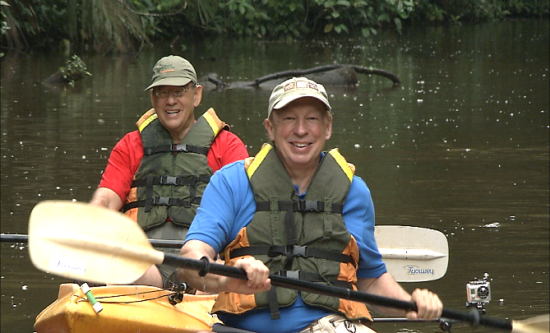
This time Richard Bangs is exploring the ecological nexus of North and South America, in the small but potent package of a country, Costa Rica. The people there are on a tear to preserve the extravagant biodiversity of their national field of dreams—and it seems to be working.

What is the secret of their success? Richard is off to find out, as he traverses a land often cited as a green beacon to the world, as well as a place two recent international studies proclaimed “the happiest country on earth!”

Costa Rica is a land of rivers wild to get to the sea, of mountains that speak with fire, and rainforests that obey no rules. It has more species of animals and plants than the United States and Canada combined. An ethnically diverse democracy, Costa Rica has literacy rates and healthcare comparable to the most developed countries in the world. It’s abolished its military, and enjoyed greater peace and political stability than all of its neighbors. But Richard says what’s brought him back to Costa Rica so many times over the years is a sense of well-being he has felt in few countries on earth.

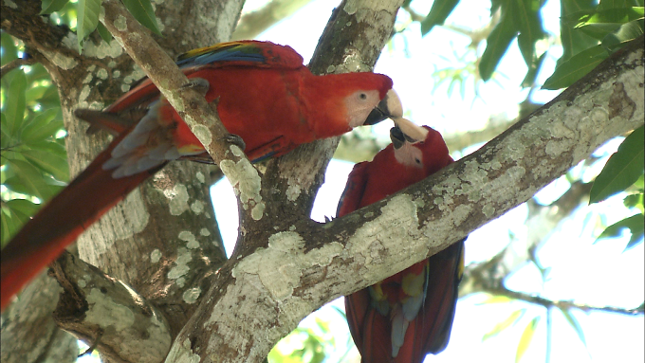
According to Bangs, “Pura Vida is a phrase I’ve been hearing ever since I first came to Costa Rica many years ago. At some point I realized I had heard it everywhere throughout the country, uttered by guides, park rangers, bus drivers and bureaucrats. But until recently, I never really considered what Pura Vida meant. I know that literally it means “Pure Life,” but is there something deeper? Could it be a clue to the roots of Costa Rica’s exceptionalism?”

Adventures with Purpose--Costa Rica
“Quest for Pura Vida”

Here, endless natural wonders rouse the faculties and excite the soul. But what Richard finds most remarkable is the sensitivity the people have to their surroundings. Costa Ricans have set aside one quarter of their land as national parks and protected areas. How did they manage this when so many people in other countries have stood by while their natural wonders were degraded or destroyed?

How did Costa Ricans fend off the miners, loggers, farmers, burners, developers and others who felled and flattened rainforests around the world? How did they trick time?

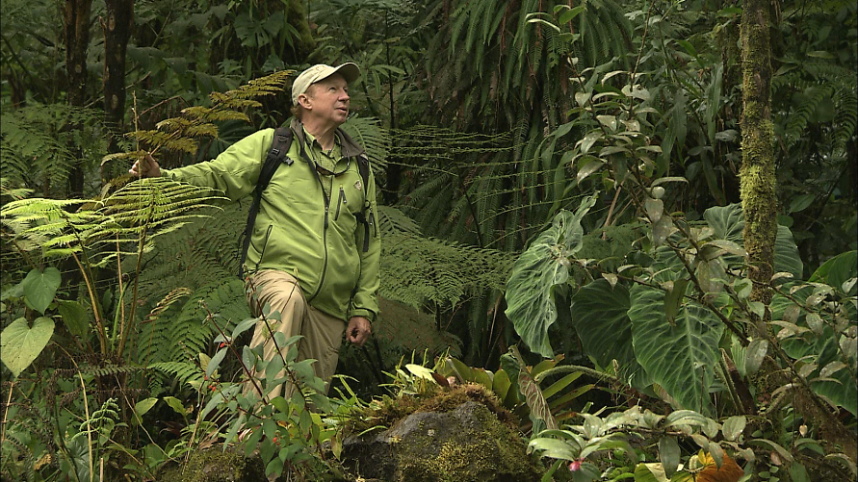
Costa Rica is the arm that reaches two continents; the hand that touches two seas. Richard begins his journey on the Pacific side, where the complex ecological mosaic that is the Osa Peninsula encircles Corcovado National Park. Then he explores the beaches at Punta Islita, Palo Verde National Park, and the Monteverde Cloud Forest, before heading to Tortuguero National Park, a tropical rain forest on the Caribbean coast.

Host and co-executive producer, Richard Bangs is a pioneer in travel that makes a difference, travel with a purpose. He has spent more than 30 years as an explorer and communicator, and along the way led first descents of 35 rivers around the globe, including the Yangtze in China and the Zambezi in Southern Africa. Richard has published more than 1000 magazine articles, 18 books, a score of documentaries and CD-ROMs; and has lectured at the Smithsonian, the National Geographic Society, the Explorers Club and many other notable venues. He writes feature articles for the Huffington Post. His latest books include Adventures with Purpose, Quest for Kaitiakitanga, Quest for the Sublime and Quest for the Kasbah, companion books for episodes in the television series.

Richard’s books and DVDs of Adventures with Purpose—Costa Rica: Quest for Pura Vida are available from Small World Productions. Each DVD contains the complete show and more than an hour of value-added bonuses including never-before-seen footage, and behind-the-scenes glimpses. DVDs are $24.95 each plus shipping. Richard’s Adventures with Purpose books are $16.95 each plus shipping. Books include essays by Richard on a number of destinations. A transcript of the Costa Rica show is included with book orders free of charge. The book and DVD together are $35.95 plus shipping. Viewers may order online at www.AdventuresWithPurpose.TV or call the order desk at 800.866.7425.

Small World Productions, Inc. of Seattle produces Richard Bangs’ Adventures with Purpose. KCTS/Seattle and Richard Bangs Productions are co-producers. KCTS is the presenting station.

Adventures with Purpose--Costa Rica
“Quest for Pura Vida”

Adventures with Purpose—Costa Rica: Quest for Pura Vida will be up-linked on APT’s HD satellite transponder. HD and standard definition “letterboxed” versions of the documentary will air on hundreds of public TV stations nationwide. Digital audio is transmitted in stereo.

Photo: The pool at Tortuga Lodge, Tortuguero National Park, Costa Rica
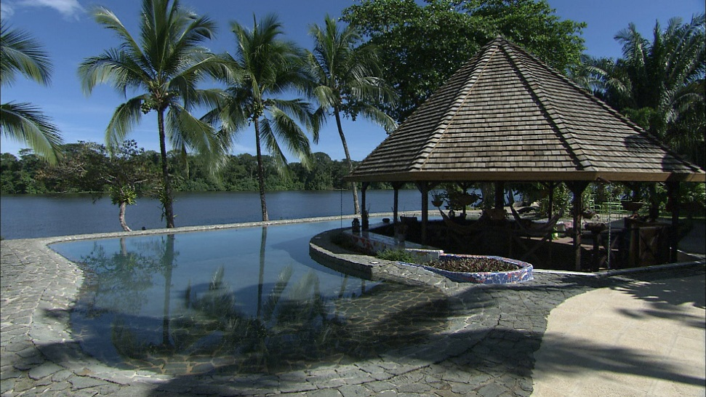
American Public Television (APT) has been a leading distributor of high-quality, top-rated programming to America’s public television stations since 1961. In 2010, APT distributed nearly half of the top 100 highest-rated public television titles. Among its 300 new program titles per year are prominent documentaries, news and current affairs programs, dramatic series, how-to programs, children’s series and classic movies, including For Love of Liberty: The Story of America’s Black Patriots, A Ripple of Hope, Rick Steves' Europe, Newsline, Globe Trekker, Simply Ming, America's Test Kitchen From Cook’s Illustrated, Lidia's Italy, P. Allen Smith's Garden Home, Murdoch Mysteries, Doc Martin, Rosemary & Thyme, The Rat Pack: Live and Swingin’, Johnny Mathis: Wonderful, Wonderful! and John Denver: The Wildlife Concert.

APT also licenses programs internationally through its APT Worldwide service. In 2006, APT launched Create® – the TV channel featuring the best of public television's lifestyle programming. APT is also a partner in the WORLD℠ channel expansion project including its web presence at WORLDcompass.org. For more information about APT’s programs and services, visit APTonline.org. For more information on Create, visit CreateTV.com.

- Corporate support for Adventures with Purpose—Costa Rica is provided in part by: Proparques (www.parkamigos.com), a non-profit organization to support the sustainability of Costa Rica National Parks
- adidas Outdoor Gear USA
- Instant Immersion Language Learning Software from Topics Entertainment (www.instantimmersion.com or www.topics-ent.com)
